**Eindproject**

Onderdelen :

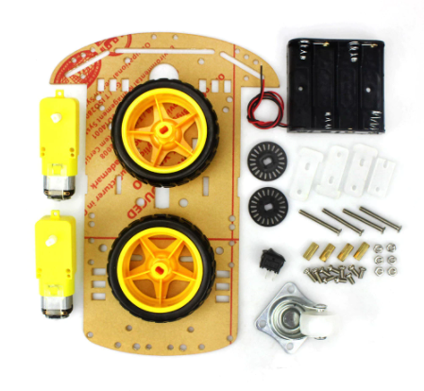

Body, wheels and motors kit

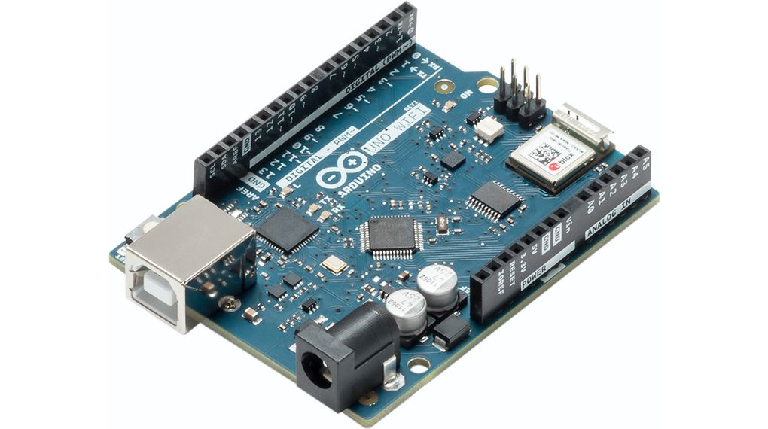

Arduino + Freenove control bord

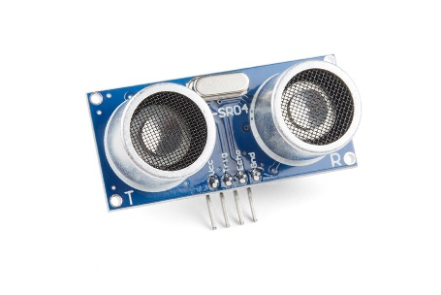

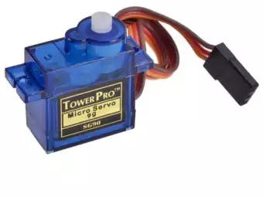

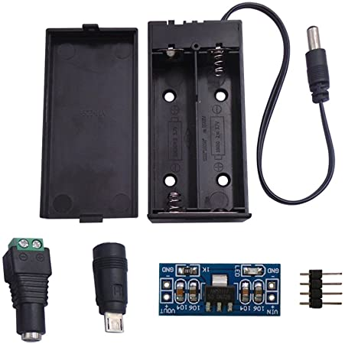

ultrasone sensor + servo motor + battery holder, 2 lithium battery’s

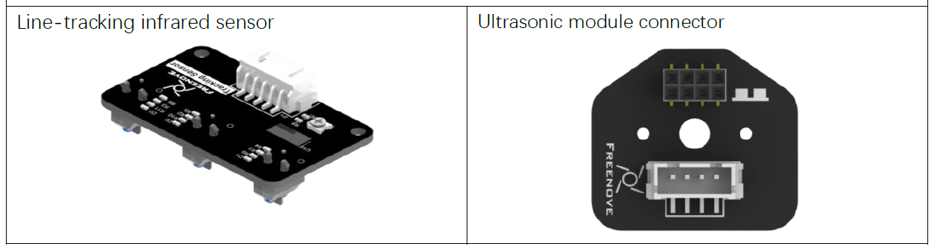

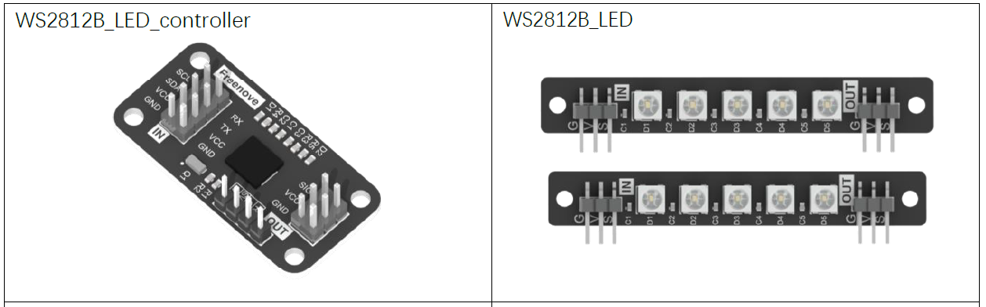

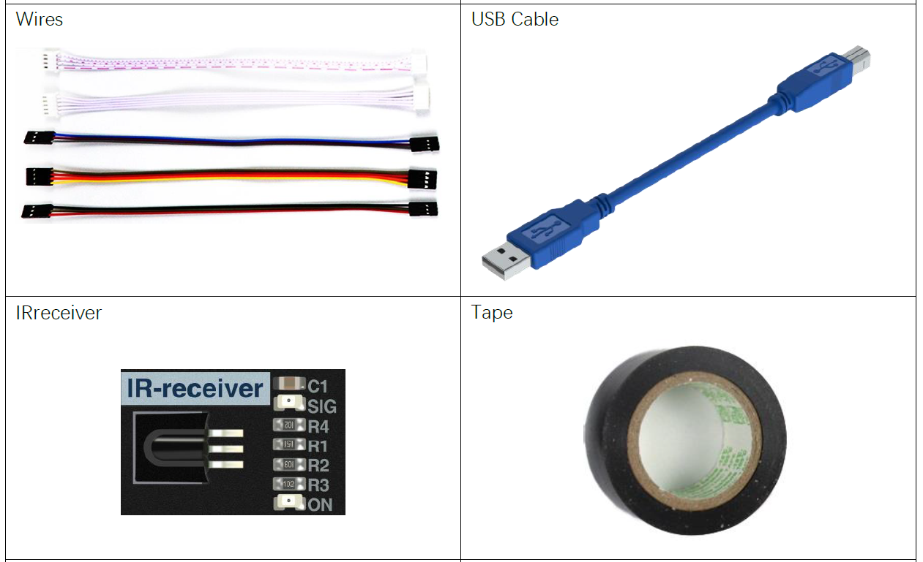

Status 02/05/2021 :

The car can currently only follow a line with the line tracking module  
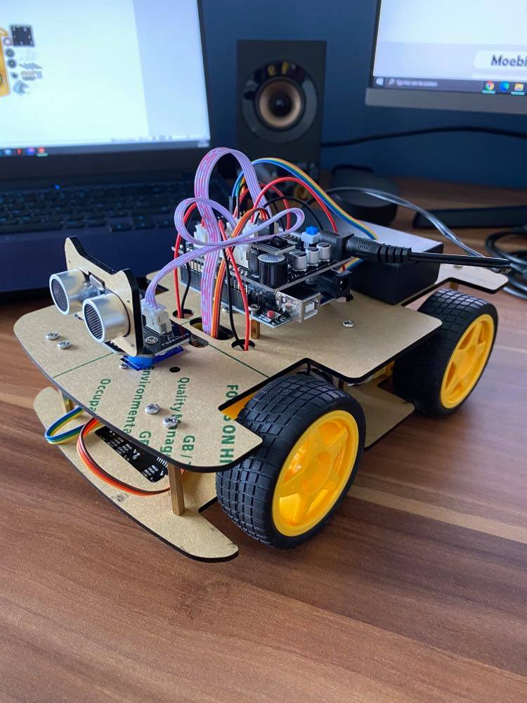

Status 31/05/2021 :

Car is fully functional

